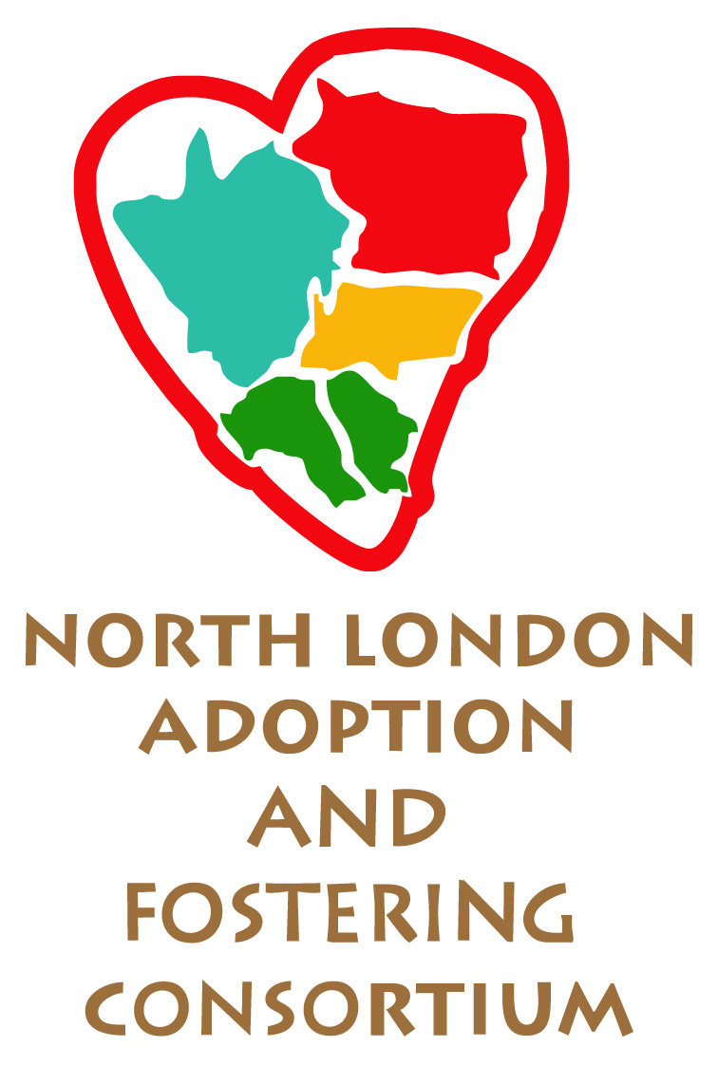
North London Fostering Consortium
Specialist Teenage Fostering Schemes
INITIAL RISK ASSESSMENT CHECKLIST and suggested risk management plan

This checklist will be provided at the time of referral. Please note that some safety issues arising from a risk assessment may indicate the inappropriateness of placing a young person in a fostering placement.

Name of young person:
Date of risk assessment:
Name of assessor:
Contact details:

Vulnerability
Is there evidence that the young person is at risk of being vulnerable as a result of the following?
Please include the young person’s previous history, and any current risk. Tick all that apply.

 | In the past | Currently
Vulnerable to the behaviour of others (e.g. bullying, abuse, neglect, intimidation, manipulation, exploitation)
Vulnerable due to a change in circumstances (e.g. separation, loss or bereavement, change of care arrangements)
Vulnerable due to their own behaviour (e.g. risk taking, drug/alcohol use, absconding, non-compliance with medication, indiscriminate use of social media)
Vulnerable due to non-engagement (e.g. with school, family, peers, helping services)
Are their indications that the young person is at risk of self-harm or suicide?
Please include the young person’s previous history, and any current risk. Tick all that apply.

 | In the past | Currently
Suicidal attempts
Suicidal ideation
Suicidal plans
Self-harm / self-injury

Risk of harm to others
Are there indicators that the young person may cause harm to others?
Please include the young person’s previous history, and any current risk. Tick all that apply.
 | In the past | Currently
Criminal convictions
Attitudes and motives such as: desire for revenge, desire for control, discriminatory beliefs
Association with dangerous networks or individuals
Violence when angry or thwarted
Bullying / threats / intimidation
Arson / fire setting
Cruelty to animals
Destruction of property
Stealing
Sexually inappropriate behaviours

Where it has been identified (above) that the young person presents a current risk please specify the risk below. Please also provide action required to manage risk within the intended fostering placement.
Add page(s) if needed.
Current risk identified from above list | Action required to manage risk within the placement

Out of hours referrals will only be accepted on young persons from the same borough as the foster carer.

