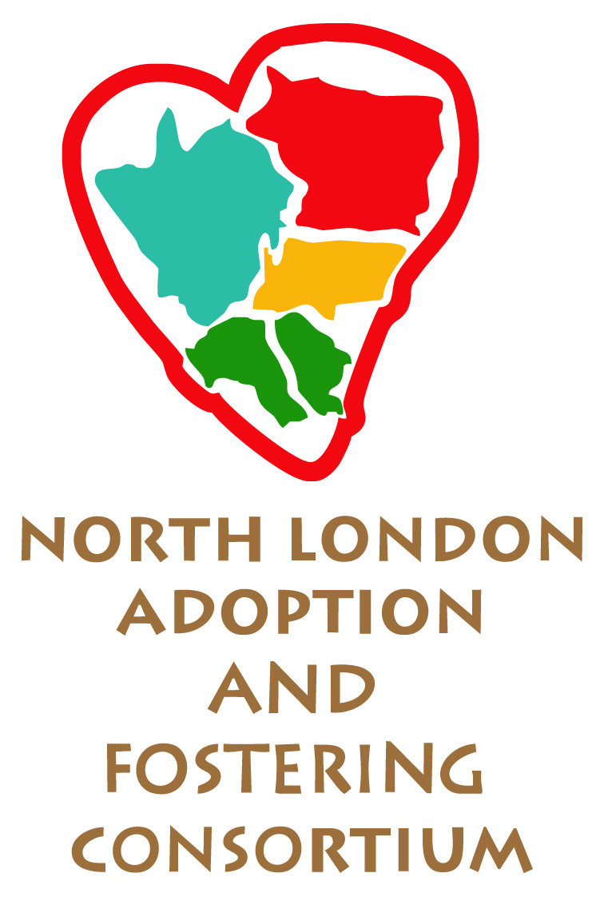
NLAFC Parent and Child Fostering Scheme
Business Process Map
PRE-BIRTH AND INFANTS UNDER ONE REFERRALS NEEDING ASSESSMENT

Possible placement need identified
Placement planning process: see next page.
If in proceedings, consultation with Legal to establish if there are any specific supervision requirement/timescales
Placement not available: Team advised to seek external placement
Resource Panel agreement, if required.

Referral Form, Viability Assessment, Adult Risk Assessment and Letter of Instruction passed to the relevant Placement Team, who will check Consortium scheme availability before considering external placement options.

Referral reviewed by Scheme SSW or her/his manager and decision taken about likely suitability
Pre-birth assessment completed (if relevant), including viability of parent and child assessment foster placement

Letter of Instruction

NLAFC Parent and Child Fostering Scheme

Business Process Map
PLANNING THE PLACEMENT

No
Yes
Is this case PLO

Legal to provide Letter of Instruction before pre-placement meeting
Letter of Instruction provided by Social Work Team before pre-placement meeting
Placement Planning meeting held no less than two weeks before date of placement at the proposed placement address

Attended by: Parent(s), Foster Carer(s), Child’s Social Worker, Foster Carer(s)’ SSW and Assessing Social Worker

Chair will be independent of the assessment process
Placement Planning meeting template used to guide discussion.
Child’s SW provides agreed documents to FC including Placement Plan, Adult Risk Assessment and signed placement agreement before placement begins
Placement made
See next page
Placement agreement completed by the Scheme SSW, sent to child’s social worker for agreement and then signed off by the parent.

NLAFC Parent and Child Fostering Scheme
Business Process Map
PLACEMENT ASSESSMENT AND REVIEW PROCESS

CP or CiC reviewing process undertaken alongside assessment process. First LAC review to be combined with review/planning meeting after the first week of placement
Placement made: 12 week (or, exceptionally, up to 16 week) assessment begins

FC provides daily support, parenting skills training and completes daily records as agreed in Pre-Placement Meeting. FC provides recordings to ASW weekly

F
FC supervised fortnightly by SSW
ASW undertakes assessment of the parent(s)

If the parent is doing well, begin active work on post-placement support package from Family Nurse Partnership or other preventative services.

Assessor files interim assessment report by sixth week
Placement review and planning meetings held:
- At the end of the first week of placement
- In fifth week of placement
- In tenth week of placement.
Attended by parent(s), FC(s), child(s) social worker, ASW, SSW and Guardian
Chair will be independent of the assessment process
Minutes completed and circulated

Final report completed by ASW by eleventh week

Placement ends

Further assessment commenced as agreed
Parent and child move back into the community, with support package
Parent and child separated and planning for permanence progressed

NLAFC Parent and Child Fostering Scheme
Business Process Map
POST PLACEMENT INVOLVEMENT OF THE FOSTER CARER

Parent and child move back into the community
Parent and child separated and planning for permanence progressed

planning for

Holding placement for the child if required / involvement in introductions of the child to another placement (not more than 2 weeks)
Possible holding placement for parent and child pending their move (with assessment carer or elsewhere)



Outreach support for 2-3 weeks as relevant and as timing of upcoming any assessment placement allows
Possible court attendance some months later

