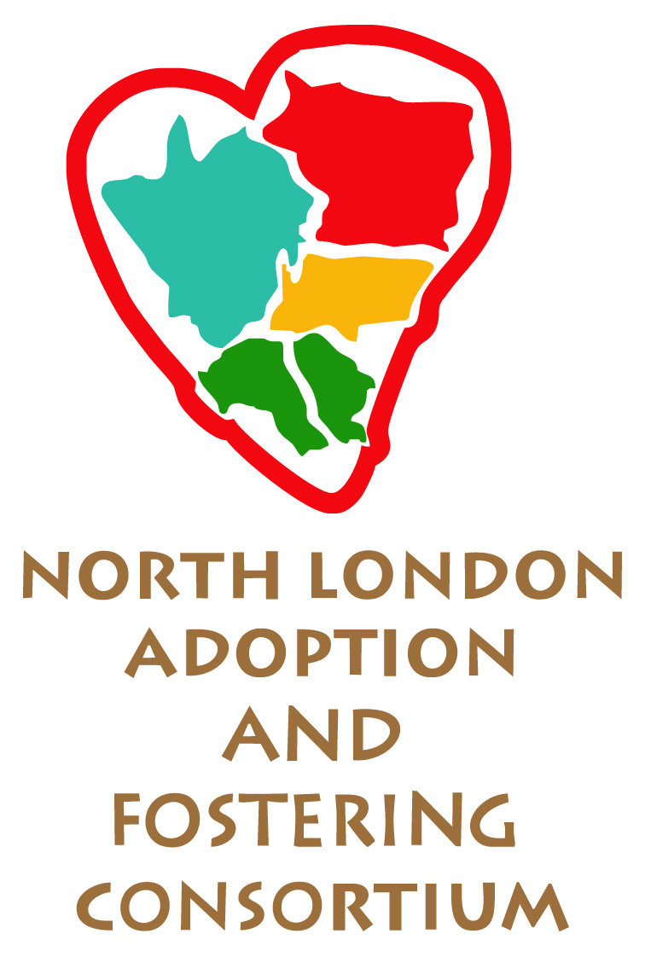
NLAFC Parent and Child Fostering Scheme

Placement Risk Management Plan

To be completed at the initial placement planning meeting
and reviewed at each placement progress meeting

Risk Area | Level of Risk  e.g. High, Medium, Low, None | Comments:  Can the risk be managed?  Detail how
Care of the Child
Known conditions or illnesses (eg HIV risk etc)

Allergies

Known areas of risk in the parent’s handling of the child’s needs

Practical Arrangements in the Foster Home
Baby equipment:
Whose is it?
Who is responsible for it?

Supervision requirements

Safety / care of the child at night

Safety issues regarding parent going out with / without the child

Health and hygiene concerns, including safe storage of any medication including methadone etc

Use of bathroom / toilet
disposal of waste:
e.g. disposable nappies

Supervision of parent in using the kitchen e.g. appliances, sharps etc

Supervision of parent preparing / storage of child’s food

Pets in the foster home--
Any potential risks to the placement

Contact arrangements

Mobile Phone: If the parent has use of a mobile are there any security risks, for example from informing others of whereabouts etc

Visitors to the foster home e.g. partner/friends/family of parent

Other significant / relevant issues

